Logging errors, debugging and testing

My function has 4 lines

Def Cal_force(mass, g)

knowing the mass and gravity you calculate the weight:

Phy_force = mass * g;

print(“%.2f kg of mass gives a weight of %.2f N” %(,phy_force))

**Error 1:**

SyntaxError: invalid syntax

debuggingpractice.py, line 1

**Possible cause:** function is not defined properly

**Correction:** def cal_force(mass,g):

**Error 2:**

SyntaxError: invalid syntax

debuggingpractice.py, line 1

**Possible cause:** Capital letter for Def should be def

**Correction:** def cal_froce(mass,g):

**Error 3:**

IndentationError: expected an indented block (debuggingpractice.py, line 2)

**Possible cause:** Line needs to be commented out using #

**Correction: #**knowing the mass and gravity you calculate the weight:

**Error 4:**

IndentationError: expected an indented block (debuggingpractice.py, line 3)

**Possible cause:** Capital letter for Phy should be phy and needs to be indented

**Correction:** phy_force = mass * g;

**Error 5:**

NameError: name 'phy_force' is not defined

debuggingpractice.py, line 4

**Possible cause:** comma inside bracket before word ,phy

**Correction:** %(phy_force))

**Error 6:**

IndentationError: expected an indented block (debuggingpractice.py, line 3)

**Possible cause**: Needs to be indented

**Correction:** phy_force = mass * g;

**Error 7:**

NameError: name 'phy_force' is not defined

debuggingpractice.py, line 4

**Possible cause**: Line 4 is not indented

**Correction:** print("%.2f kg of mass gives a weight of %.2f N" %(phy_force))

After running function, Error 8:

NameError: name 'phy_force' is not defined

**Possible cause:** Missing argument ‘mass’ inside the bracket.

**Correction:** print("%.2f kg of mass gives a weight of %.2f N" %(mass,Phy_force))

**Corrected code should look like:**

def Cal_force(mass, g):

#knowing the mass and gravity you calculate the weight:

phy_force = mass * g;

print("%.2f kg of mass gives a weight of %.2f N" %(mass,phy_force))

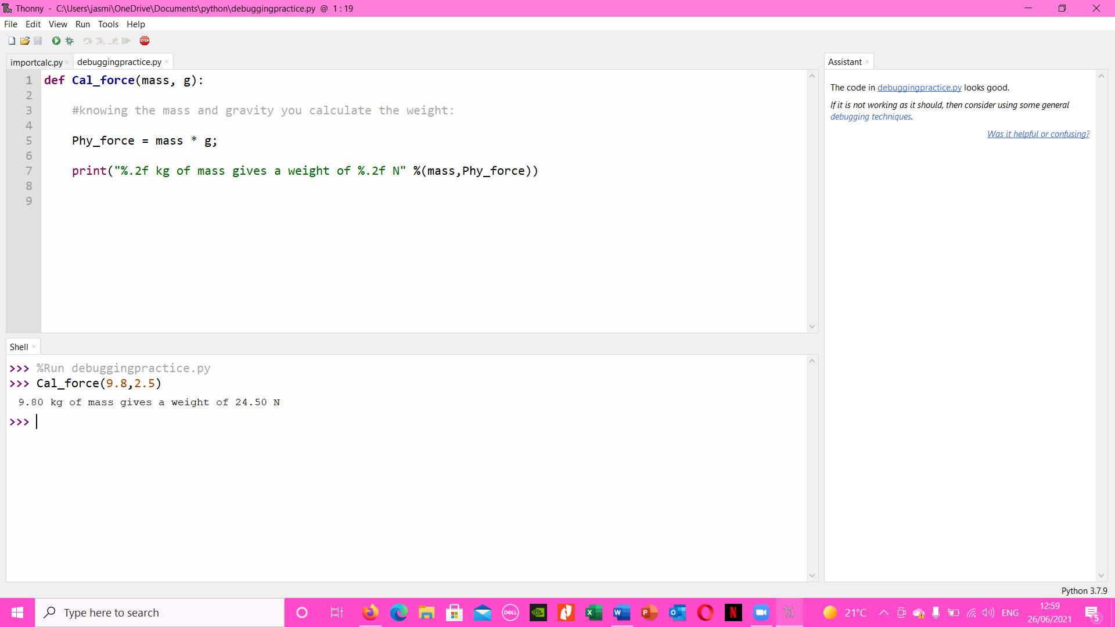**Working code:**

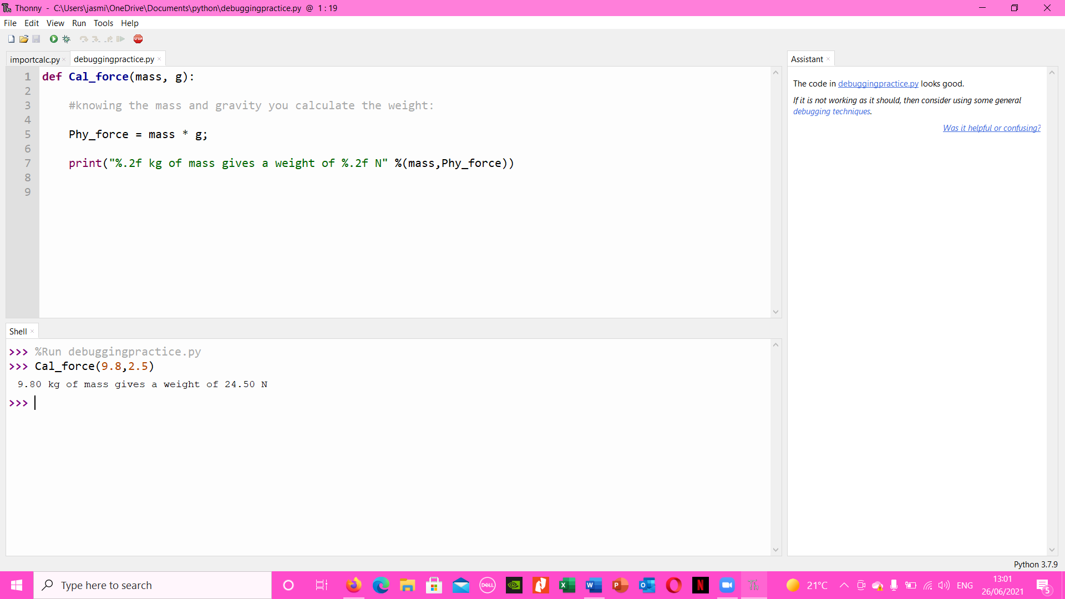

|  |  |
| --- | --- |
| Cal_force(0,9.8) |  |
| Cal_force(1,9.8) |  |
| Cal_force(2,9.8) |  |
| Cal_force(3 ,9.8) |  |

**The expected outputs clearly match the python outputs.**